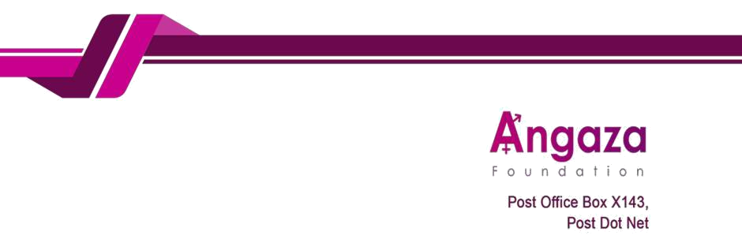

29th October 2025

To: The Bank Manager FDH

Bank

Umoyo Branch of

Blantyre

Dear Sir/Madam,

Subject: Instruction to Funds from USD 1860100042935 Account to MWK accounts

We hereby instruct you to transfer funds from our USD account 1860100042935 to MWK account as detailed

below.

- Exchange rate as today: 1,751 Receiving accounts detail:
Account name | Account number | Bank | Amount | Currency
Angaza Foundation Limited | 1850004691037 | FDH | 4,200 | Kwacha

Purpose of transfer: This transfer is payment of Public Lecture.

Thank you for your prompt assistance with this matter. For any queries, please contact me on

+265 996 263 843 or godfreychifuniro@gmail.com

Your Faithfully,

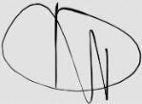

Godfrey Kambewa

Executive Director

Doreen Mwenelupembe

Programs Manager

